# CS 255 System Design Document Template

This template lays out all the different sections that you need to complete for Project Two. Each section has guidance to prompt your thinking. You will need to continually reference the interview transcript as you work to make sure that you are addressing your client’s needs. There is no required length for the final document. Instead the goal is to complete each section based on what your client’s needs are. Remove this note when you are finished, and replace all bracketed text with the relevant information.

## UML Diagrams

### UML Use Case Diagram

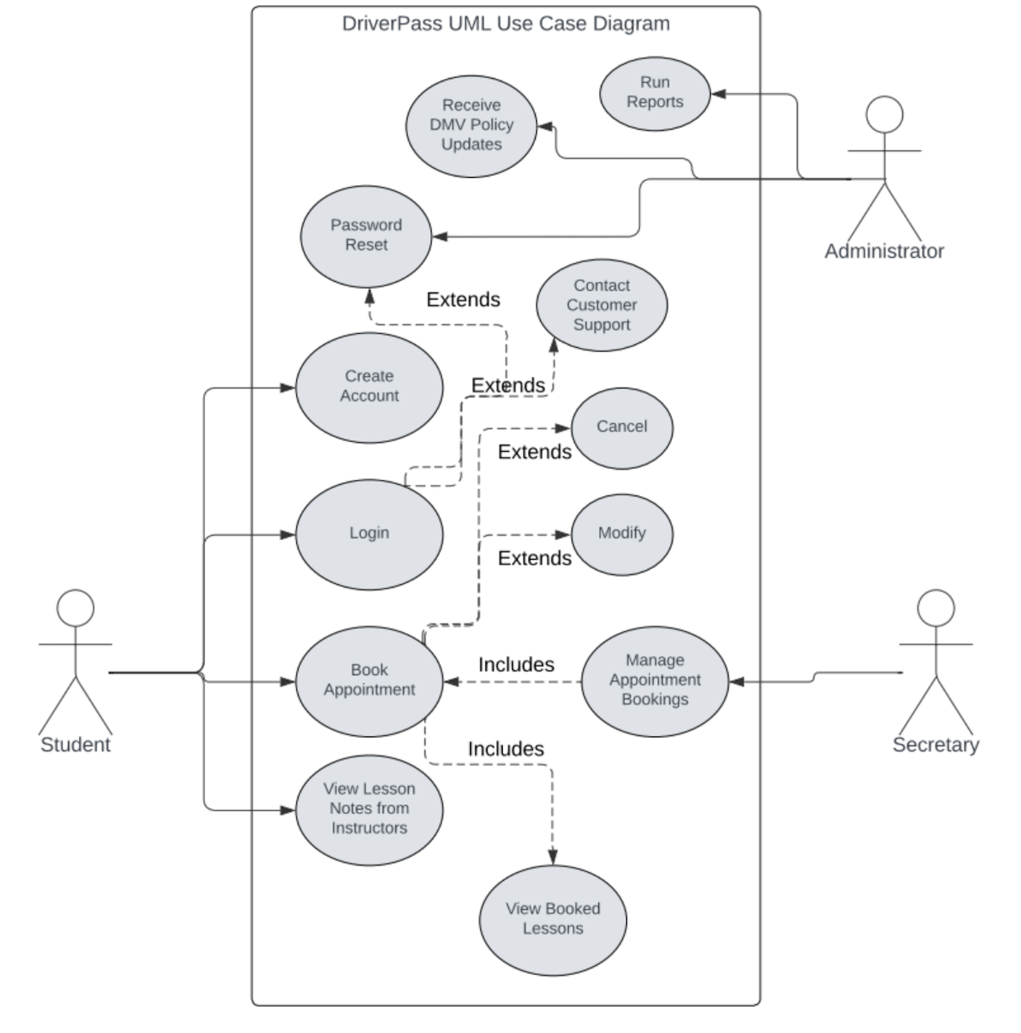

### UML Activity Diagrams

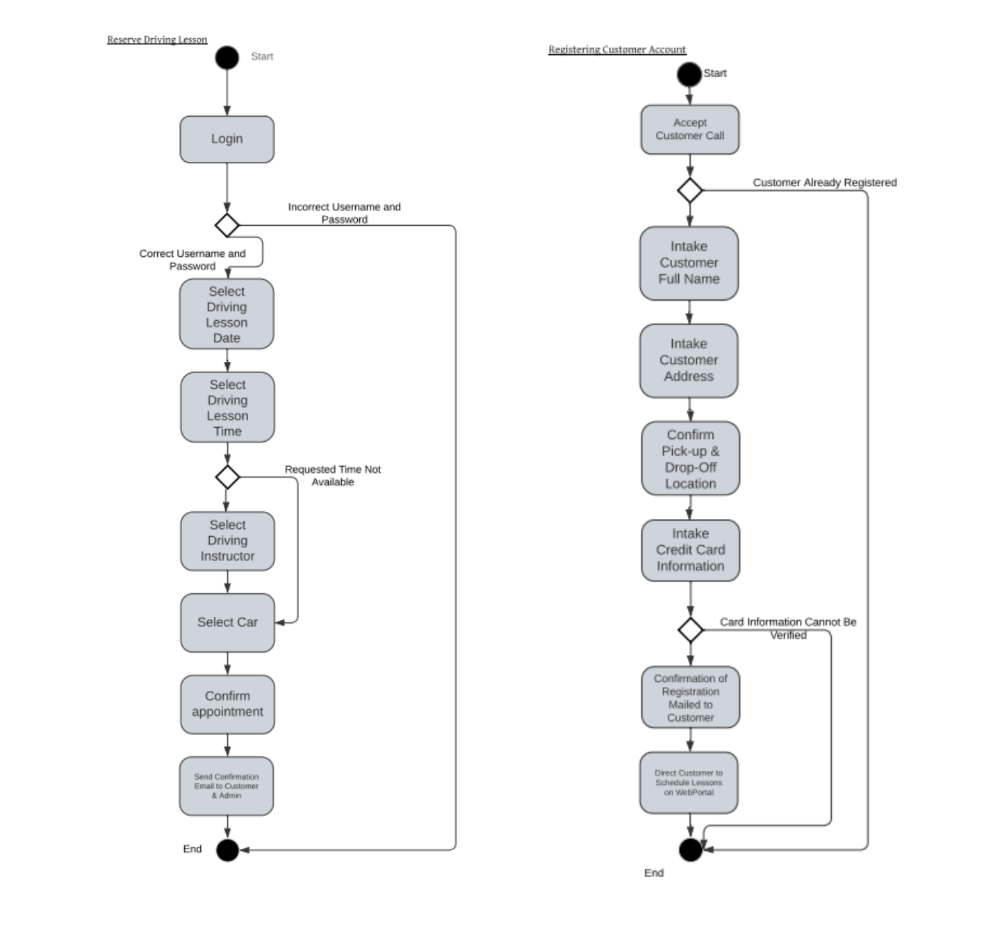

### UML Sequence DiagramImage

### UML Class Diagram

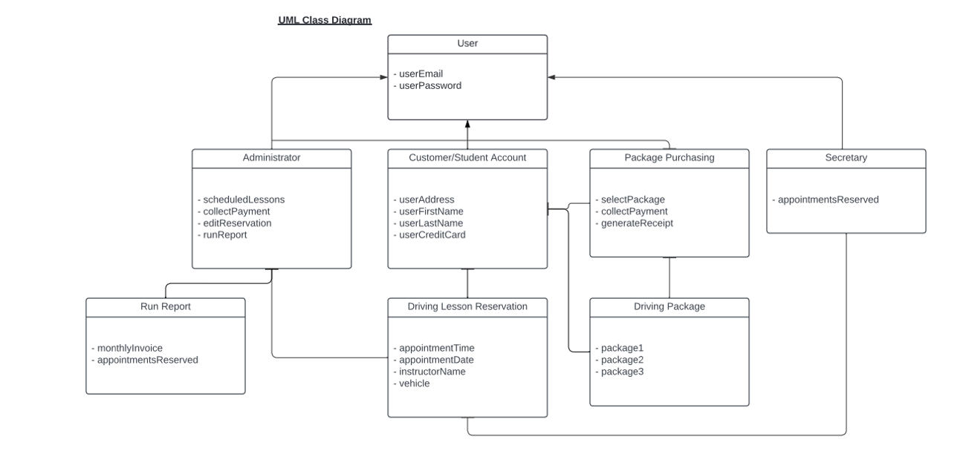

## Technical Requirements

Since this is a smaller business with potential for growth, it's advisable to use a cloud-based server due to its cost-effectiveness and scalability. All administrative staff should be equipped with computers running a Windows operating system to access the system. An automated backup system is essential for safeguarding sensitive data, such as customer and administrative information, along with security software to protect against viruses. A reliable internet connection is crucial for all administrative members to stay updated on changes in schedules, reservations, or policies from the DMV. Additionally, access to DriverPass’s web portal should be compatible with popular operating systems like MacOS, Windows, iOS, and Android to cater to a wide customer base.